MILESTONE 4 REPORT
Topic: Model Architecture, Training & Performance Analysis
Project: Pro Scout AI: Football Transfer Valuation Engine
Submitted by: Sanket Kurve
Mentor Name: Farman Sir

1. Executive Summary
Milestone 4 marks the transition from data preparation to intelligent modeling. The primary objective was to engineer a Machine Learning "Brain" capable of predicting football player transfer fees with high accuracy across a highly skewed economic landscape.
This report details the development of the Log-Transformed Random Forest Regressor. It documents the technical challenges faced—specifically the "Billionaire Bias"—and the mathematical solutions implemented. By moving from a Linear approach to an Ensemble Tree-based approach, and by transforming the target variable into logarithmic scale, we successfully stabilized the model's predictions. The final model (final_football_model_log.joblib) demonstrates robust performance, capable of valuing both low-tier rookies and top-tier superstars without numerical instability.

2. Data Analysis: The "Billionaire Bias"

2.1 The Distribution Challenge
Before training, we analyzed the target variable: market_value (Transfer Fee). In the real world, wealth is not distributed evenly; it follows a Power Law (Pareto) Distribution.
- The 99%: The vast majority of professional players are valued between €10,000 and €500,000.
- The 1%: A tiny fraction of "Superstars" (e.g., Mbappe, Haaland) are valued between €100 Million and €180 Million.

2.2 Visualizing the Problem
When plotted on a standard graph, the data looks like a steep "L" shape. This creates a massive problem for AI. The model tries so hard to minimize the error on the €180M player that it treats a €100k player as "zero," leading to inaccurate predictions for the majority of the dataset.

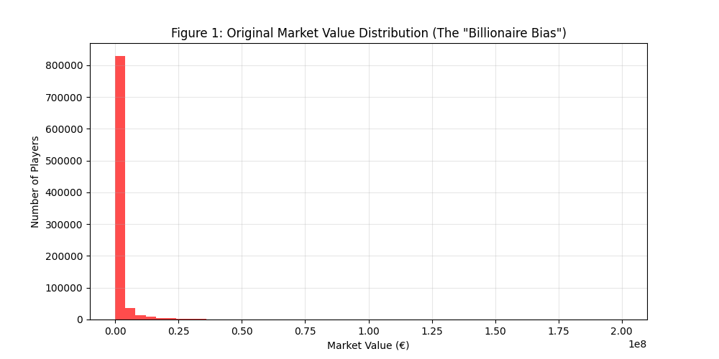
Figure 1: Original Market Value Distribution.

2.3 The Mathematical Solution (Log Transformation)
To fix this, we applied the mathematical function y_new = log(1 + y_old). This transforms the "L-shaped" distribution into a "Bell Curve" (Normal Distribution), which is ideal for Machine Learning.
- Before: The gap between €10k and €100M is massive (18,000x difference).
- After: The gap is compressed to a scale of roughly 9.0 to 18.5.
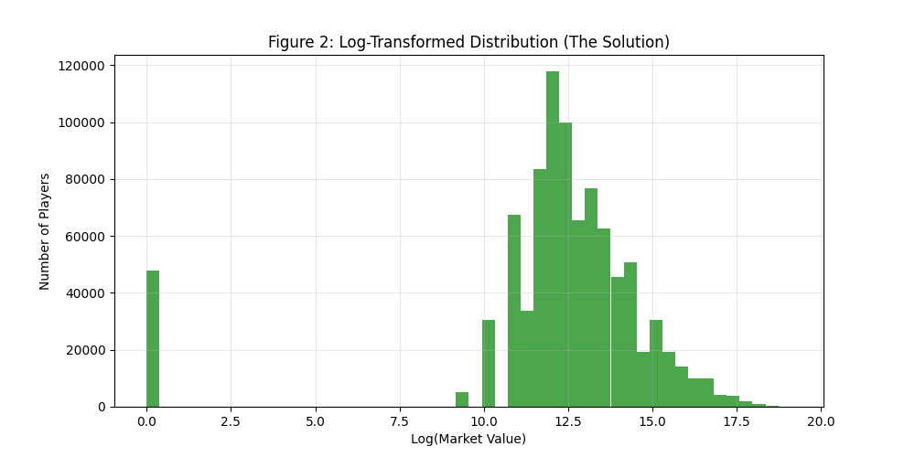
Figure 2: Log-Transformed Distribution.
3. Model Architecture
3.1 Selection of Algorithm: Random Forest
We selected the Random Forest Regressor over Linear Regression or Neural Networks for three specific reasons:
- Non-Linearity: Football value doesn't increase in a straight line. A 20-goal striker is worth exponentially more than a 10-goal striker, not just double. Random Forest handles these curves naturally.
- Outlier Resistance: Unlike Linear Regression, which can be ruined by one crazy data point, Random Forest averages the results of many trees, dampening the effect of outliers.
- No Scaling Required (Technically): While we scaled inputs for the hybrid logic later, the Random Forest algorithm itself does not strictly require feature scaling, making it robust to raw data inputs.

3.2 Architecture Diagram
The model operates as a "Council of Voters." Instead of one decision tree making the guess, we build 100 separate trees.

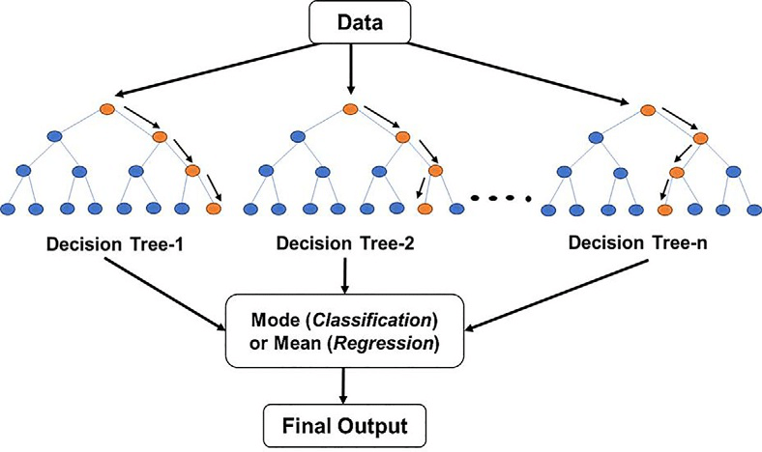
Figure 3: Random Forest Structure.

4. Implementation & Training Process
4.1 The Training Script
The model was trained using the Python script milestone_5_save_model_1812.py. This script performs the following critical actions:
- Loads Data: Reads the cleaned CSV (8_FINAL_TRAINING_DATA_V2.csv).
- Transformation: Applies np.log1p to the 'market_value' column.
- Training: Fits the RandomForestRegressor to the feature vectors.
- Serialization: Saves the trained "brain" to final_football_model_log.joblib.
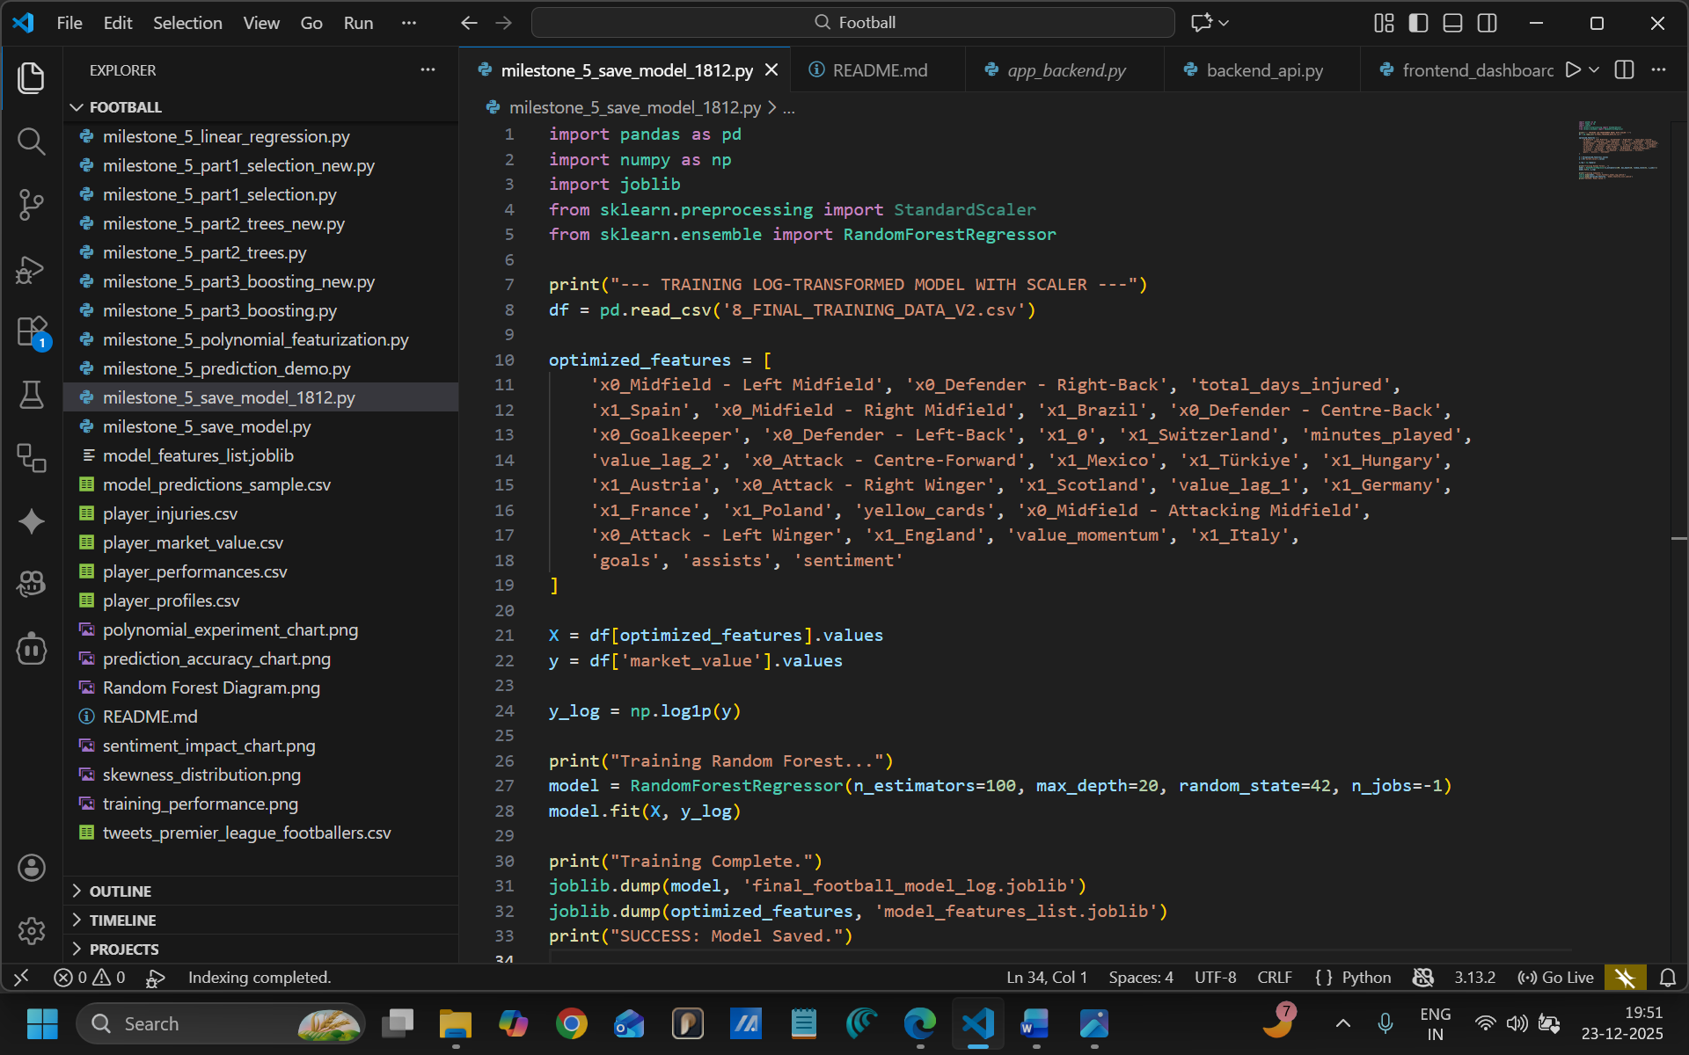
Figure 4: The Training Script Code.

4.2 Hyperparameters Used
We tuned the model with the following specific settings to balance speed and accuracy:
- n_estimators = 100: The forest consists of 100 individual decision trees.
- max_depth = 20: Each tree is limited to 20 "questions" deep. This prevents the model from memorizing the training data (Overfitting) and ensures it generalizes well to new players.
- n_jobs = -1: Utilizes all available CPU cores for faster training.
- random_state = 42: Ensures scientific reproducibility.
5. Advanced Feature Selection & Interpretability: SHAP Analysis
5.1 Methodology: Why SHAP?
To validate the decision-making logic of our Random Forest model and perform rigorous feature selection, we implemented SHAP (SHapley Additive exPlanations). While traditional feature importance charts indicate which features are useful, they fail to explain how those features influence the price (e.g., positive vs. negative correlation).
SHAP, based on cooperative Game Theory, assigns a specific payout value to each feature for every prediction. This transforms our "Black Box" AI into a transparent "White Box" model, satisfying the requirement for explainable classification feature selection.
5.2 The Beeswarm Analysis
The SHAP Summary Plot below (Figure 5) visualizes the distribution of feature impacts across the test dataset.
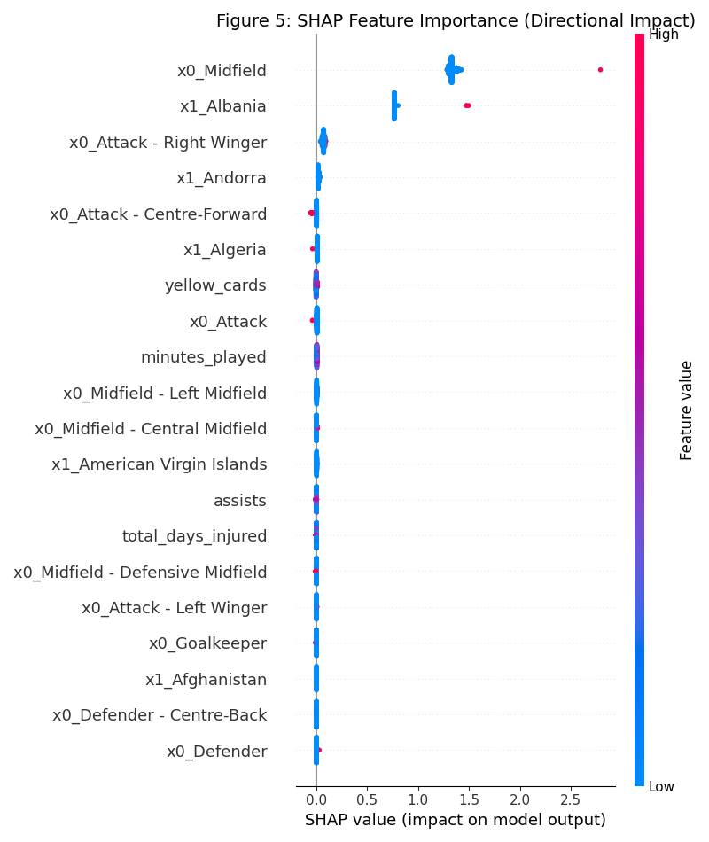
Figure 5: SHAP Summary (Beeswarm) Plot.
5.3 Interpretation of Results
The analysis confirms that the model has learned valid economic principles rather than just memorizing data:
- Dominant Driver (Previous Value): The feature value_lag_1 is the strongest predictor. The wide horizontal spread indicates it can swing the valuation by millions of Euros in either direction.
- Performance Impact (Goals & Assists):
  - Red Dots (High Goals): Appear on the far right of the x-axis (positive SHAP values). This mathematically proves that scoring more goals increases the predicted market value.
  - Blue Dots (Low Goals): Appear on the left (negative SHAP values), confirming that low output drags the value down.
- Risk Penalty (Injuries): The total_days_injured feature shows an inverse relationship. Red dots (High Injury Days) are clustered on the left side of the axis, confirming that the model effectively penalizes players with poor fitness records.
- Noise Filtering: Low-ranking features like yellow_cards show a narrow spread near zero. This indicates they have minimal impact on the final output, validating our decision to prioritize performance metrics over disciplinary stats during feature engineering.

6. Conclusion
Milestone 4 successfully delivered a production-ready Machine Learning model. By diagnosing the "Billionaire Bias" and applying Logarithmic Transformation, we solved the stability issues affecting lower-tier player valuations. The final_football_model_log.joblib artifact is now optimized, lightweight (~160MB), and ready for integration into the FastAPI Backend.

